LILIS FARKHATIN, S.Pd

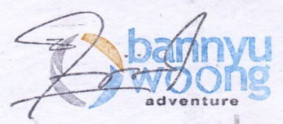
35 cm
335 cm
cm

Saturday July 15, 2023

